**[Michael Galarnyk](https://medium.com/@GalarnykMichael?source=post_page-----f8e188f9a63d--------------------------------)**

Data Scientist <https://www.linkedin.com/in/michaelgalarnyk/>

**Install Python (Anaconda) on Windows**

Anaconda is a package manager, an environment manager, and Python distribution that contains a collection of many open source packages (numpy, scikit-learn, scipy, pandas to name a few).

If you need additional packages after installing Anaconda, you can use Anaconda’s package manager, conda or pip to install those packages. This is highly advantageous as you don’t have to manage dependencies between multiple packages yourself.

Conda even makes it easy to switch between Python 2 and 3 In fact, an installation of Anaconda is also a common way to install Jupyter Notebooks.

This tutorial includes:

* How to download and install Anaconda on Windows
* How to test your installation

1.) Go to the [Anaconda Website](https://www.anaconda.com/download/#windows) and choose either a Python 3.x graphical installer (A) or a Python 2.x graphical installer (B). If you aren’t sure which Python version you want to install, choose Python 3. Do not choose both.

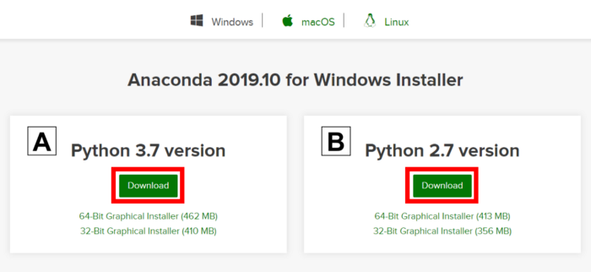

2. Locate your download.

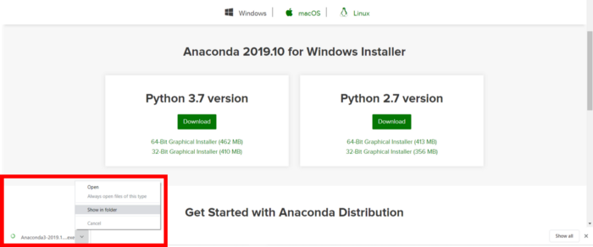

Ideally, you open/run the file as administrator.

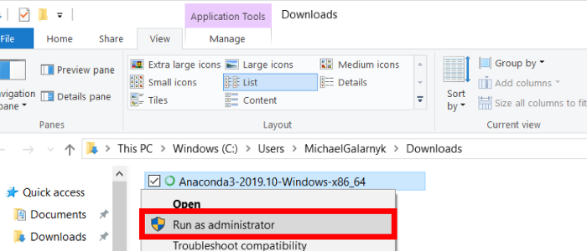

Installing as administrator is for the case you don’t have permission install anaconda in the location you want or to add anaconda to your path.

When the screen below appears, click on Next.

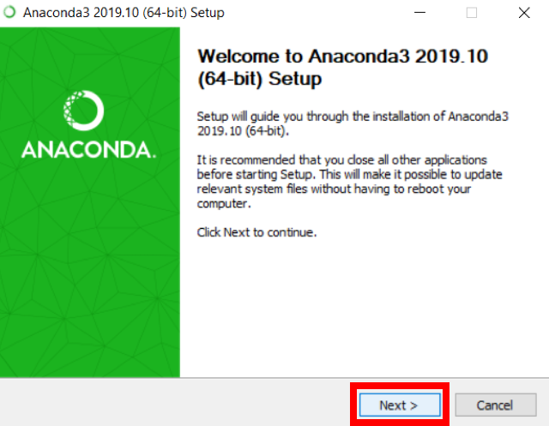

3. Read the License Agreement and click on I Agree.

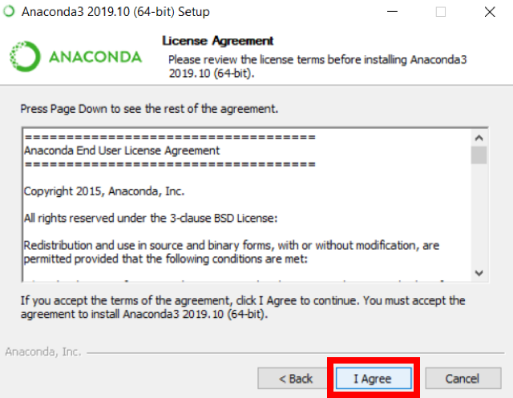

4. Choose either Just Me (recommended) or All Users.

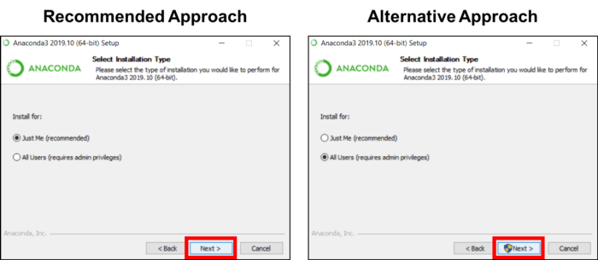

If you aren’t sure which to select, choose Just Me as this can mitigate potential issues if you don’t have administrator privileges.

5. Please make a note of your installation location (1) and then click Next (2).

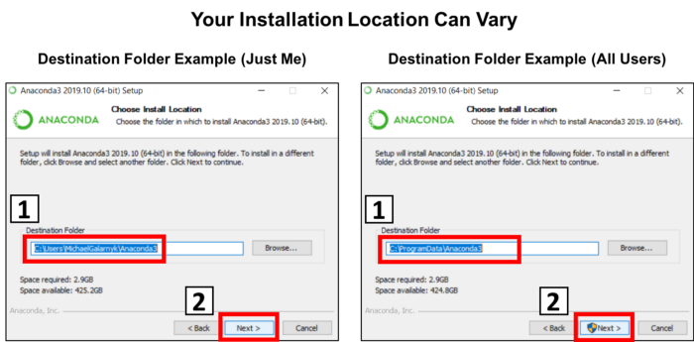

Your installation location can vary so keep note of where you installed anaconda. In the example image on the left, the path is similar to if you selected “Just Me” for step 4. In the example image on the right, the path is similar to if you selected “All Users” for step 4.

6. This is an important part of the installation process. The recommended approach is to not check the box (1) to add Anaconda to your path. This means you will have to use Anaconda Navigator or the Anaconda Command Prompt (located in the Start Menu under “Anaconda”) when you wish to use Anaconda (you can always add Anaconda to your PATH later if you don’t check the box). If you want to be able to use Anaconda in your command prompt, please use the alternative approach and check the box. Click on Install (2).

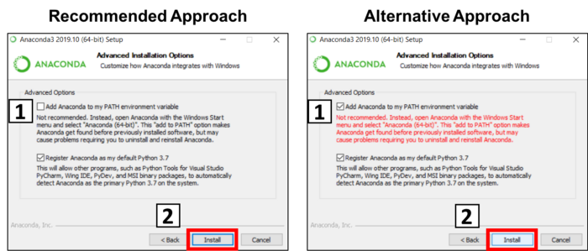

This is important. Consider what you are doing in this step.

7. Click on Next.

8. You can install PyCharm if you like, but it is optional. Click on Next.

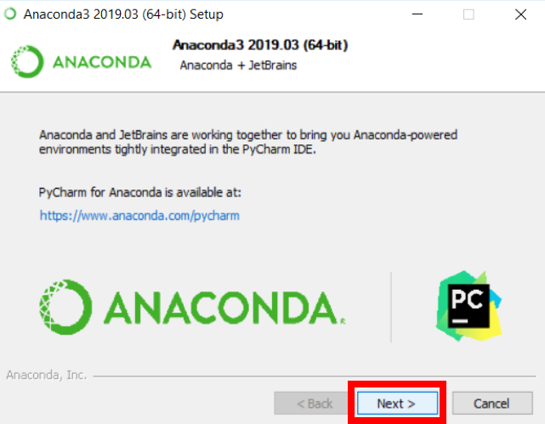

9. Click on Finish.

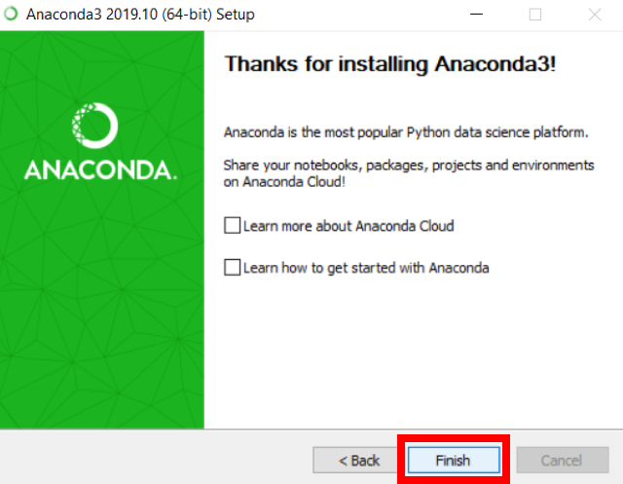

**How to Test Your installation**

A good way to test your installation is to open a Jupyter Notebook. You can do this through either Anaconda Prompt or Anaconda Navigator. Locate Anaconda Navigator and Click on Anaconda Navigator.

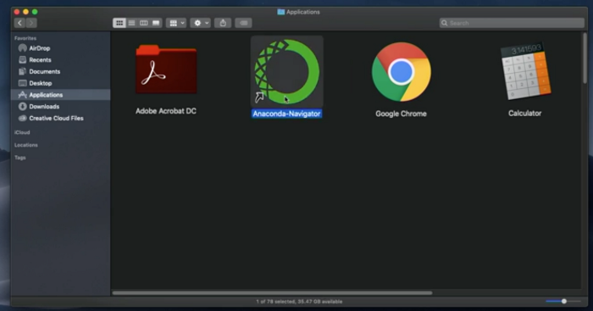

Image Source: [https://www.linkedin.com/learning/python-for-data-visualization](https://www.linkedin.com/learning/python-for-data-visualization/value-of-data-visualization)

2. Under Jupyter Notebook, click on Launch.

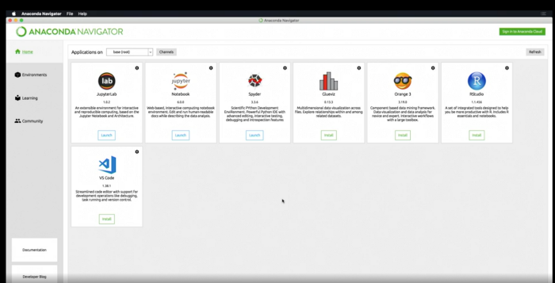

Image Source: [https://www.linkedin.com/learning/python-for-data-visualization](https://www.linkedin.com/learning/python-for-data-visualization/value-of-data-visualization)

Anaconda Prompt

1. Locate Anaconda Prompt.

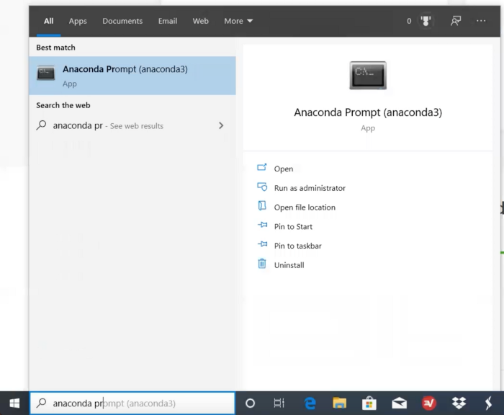

2. Type the command below to see that you can start a Jupyter (IPython) Notebook.

jupyter notebook

